Design Document

CIS 4911 - Senior Project (U01)
Event Driven Cloud Computing
Cory McAn
February 26, 2015
Jason Dettbarn

Copyright and Trademark Notices
All Addigy specific logos and slogan material is copyright Addigy, Inc. All other materials developed for this project are available open source under MIT License:
http://opensource.org/licenses/MIT

Abstract
The market for IT monitoring tools has been growing in the past years, but there is still a lack of robust IT alerting tools for Mac computers. This study describes and evaluates the design of an IT monitoring solution that runs in the cloud and sends real time messages to the IT admin when there are alerts. Due to the lack of effective monitoring tools for Mac, a need for efficiency when handling big data and the need to reduce cost of managing the service, we have decided to host the alerting service in the cloud.

The cloud implementation allows each instance of the functions that send the alerts to run simultaneously so many instances can alert without waiting for the others to finish. This allows the service to handle all the data needed to support our IT admins, and is a viable backend solution to the auditing service which can then be integrated into the front end Web Dashboard in later versions.

Chapter | Page
1. Introduction | 4
1.1 Problem Definition | 4
1.2 Design Methodology | 4
1.3 Definitions, Acronyms, and Abbreviations | 5
1.4 Overview of Document | 5
2. System Design | 6
2.1. Overview | 6
2.2. Subsytem Decomposition | 7
2.3. Hardware and Software Mapping | 7
2.4. Persistent Data Management | 8
2.5. Security/Privacy | 8
3. Detailed Design | 9
3.1. Overview | 9
3.2. Static Model | 10
3.3. Dynamic Model | 13
3.4. Code Specification | 14
4. Glossary | 14
5. Appendix | 16
5.1. Appendix A | 16
5.2. Appendix B | 24
5.3. Appendix C | 25
5.4. Appendix D | 27

- Introduction

Event Driven Cloud Computing is an application that processes audit data on the backend using event triggers that reside in AWS S3 and can be configured for different types of events. This document outlines all the design methodologies used, as well as the models and system architechtures created for this software.
First I will discuss the problem this technology aims to solve and how it attempts to solve it. I will then explain the design methodologies used in order to successfully implement the software. The end of this document contains the diagrams related to the system design and diaries of team meetings.

1.1. Problem Definition
In the world of IT, many professionals lack the tools necessary to manage Mac machines and respond to alert scenarios on their client machines. This project aims to accomplish this in an efficient and cost effective manner, using cutting edge technology that is far superior to the typical server implementation.
Currently audit data is processed by a remote server using polling to get updated information for machines. This implementation allows audit data to simply be pushed on demand and processed, without any need for running servers, and also able to process many audit files at once.

1.2. Design Methodologies
This project involves 2 major frameworks, S3 and Lambda. By leveraging these services, we can avoid having any sort of database, and avoid needing to design any infrastructure outside of the Lambda functions that are run on events. This allows us to focus on making the functions as efficient as possible as the services we are using are already optimized to run the code efficiently in the cloud.
This project was designed with an agile approach, where the requirements shaped the implementations as they shifted throughout the development of the project. The development process consisted of 5 sprints, each two weeks, where we set out to meet the expectation of our mentor and used our retrospectives to move forward in the following weeks.
The system was modelled using UML Use Case Diagrams, Class Diagrams, and Sequence Diagrams.

1.3. Definitions, Acronyms, and Abbreviations
Some of the acronyms or abbreviations used throughout this document can be found detailed here:
- AWS (Amazon Web Services) – The cloud infrastructure where client computer audit data will be stored.
- Audit Data – Data from client computers compiled using the client side application for Addigy that contains information related to hardware and software configurations on the machine.
- S3 Bucket – The storage that AWS uses for all files. To be used to house the client audit data.
- Lambda Function – Code written in Node.js that runs when AWS recognizes a specific event. Many functions can run simultaneously and will live until they have completed execution.
- JSON – File format that all client audit data will be stored in. Data is encapsulated for easy access using brackets to group related data.

Overview of Document
This document will serve to outline and describe all of the project’s System Implementations and Design. This includes:
- High level description of the system
- Decomposition of all of the subsystems that make up the system
- Hardware and Software mapping
- Data manipulation and transformation
- System security and privacy
- The static and the dynamic model of the system
- Code specifications for the main control section in each system

2. System Design
This section explains the detailed breakdown of the system into its components.

2.1. Overview
Event Driven Cloud Computing is a back end audit processing service that contains many different systems in the Lambda functions that process the audits. It follows a three-tier architecture that separates the Presentation, Logic and Data Tiers, shown in the System Design diagram in Appendix C.
The presentation tier consists of:
- PubNub Console displays the alert messages on the developer console for the initial PubNub implementation.
- Dedicated Console displays the alert messages on a dedicated front end demo page that color codes the alert message output based on the name of the machine posting the alerts.
The logic tier consists of the primary Lambda code that processes the audits when triggered by an audit put event. It is composed of:
- ConsolidateAuditFiles which puts all of the current audit data in the bucket into one file so that we can maintain the previous audit state.
- TriggerOnThreshold is the original alerting function that has alerts for Harddisk and Firewall status.
- TriggerOnNewThreshold is the expanded functionality of the previous function that now checks the previous audit state to alert only on NEW alerts.
- SendPubNubAlert triggers alerts on Harddisk and Firewall, and then sends those messages to the PubNub developer console.
- ConfigAlerts has the same functionality as above but now with the added ability to modify how alerts work. The _config.json file allows the backend admin to change the search variables, threshold values, and whether or not to send an alert on a given static.
- TriggerOnBatteryThreshold has the previous functionalities and also alerts on battery health and percentage.
- AlertAntivirusLog has the previous functionalities and also alerts on Antivirus quarantine status.
- MultipleRunTester has the previous functionalities and has been tweaked to work with up to 11 test audits being uploaded at once in a mass upload.

The data tier consists of the S3 Buckets and the Addigy API, which are already created and needed no modification or design. The S3 buckets hold the audit information as it is pushed in to be processed, and the Addigy API is the service that facilitates the push of the audit data into S3.

2.2. Subsystem Decomposition
The PubNub developer console was already created and did not need any modification.

The Dedicated console was created in HTML and CSS, with a javascript portion that processes the PubNub messages coming in on the specified channel and color codes the output based on hostname.

All of the Lambda functions that make up the Logic Tier were written in Node.js, as at the time of development, AWS Lambda required Node.js code for Lambda Functions. Each of these functions accomplishes a set of tasks needed to process the audit files and give the IT Admin some meaningful output regarding the alerts.

PubNub is a messaging service that allows online communication using a Publish-Subscribe architecture. In our case, we only require the publishing aspect in the Lambda code, and in the Dedicated Console we subscribe to the publish channel to view the messages. By subscribing to a channel, a machine connects a TCP socket to PubNub through which it receives any messages published to the channel. The message will be delivered to all subscribers, and can have many subscriber channels open at once.

The Addigy API interacts with the client machine and runs the audit, at which point the audit is put into the S3 Bucket for that organization. The Addigy API was already built and I leveraged it to obtain the audit data for use in my Lambda Functions.

2.3. Hardware and Software Mapping
The hardware and software that were used in this project were integrated in the following ways:

- AWS Cloud Infrastructure
- The S3 Bucket is configured to run code in response to certain events. In our case it is configured to run the specified Lambda Function on any “Put” of a file into the organization Bucket. This means that after a file has been uploaded, the Lambda function will run. This infrastructure serves as a ‘server-less server’ that can handle new jobs on demand whenever there is new audit data to process.
- Server Machine
- We use a linux virtual machine to host all of the project files, and to host the demo page. The server runs an Apache server. This server runs the Dedicated Console page when navigating to the server address.

2.4. Persistent Data Management
This application currently does not handle any persistent data. All audit data is pushed into the buckets and can be managed by the back end IT Admin that has control of the S3 buckets. The PubNub Keys live inside of the configuration file in the bucket so that the admin can control which PubNub Channel they want to publish their alerts to.

2.5. Security/Privacy
This application currently does not handle authentication as it is concerned with the backend processing of audit data. The IT Admins that would be accessing this data already have the credentials necessary to view it.
Data encryption and security is handled by AWS and that is why it was a prime candidate for this project.
The default Linux settings were used in the VM that was provided. No other modifications were made.

- Detailed Design
This section explains the details of the subsystems that make up Event Driven Cloud Computing.

Overview
The Overall System uses a Model-View-Controller design with the Dedicated Console, S3 Buckets and Addigy API.

The PubNub developer console was already created and serves as a view.

The Dedicated console was created in HTML and CSS, with a javascript portion that processes the PubNub messages coming in on the specified channel and color codes the output based on hostname. This console serves as a view for the IT admin to see the alert messages.

All of the Lambda functions that make up the Logic Tier were written in Node.js, as at the time of development, AWS Lambda required Node.js code for Lambda Functions. Each of these functions accomplishes a set of tasks needed to process the audit files and give the IT Admin some meaningful output regarding the alerts. The functions that send messages require the PubNub API to publish to the desired channel. These functions are the logic that run in the S3 Bucket which can be considered the model in our architecture.

PubNub is a messaging service that allows online communication using a Publish-Subscribe architecture. In our case, we only require the publishing aspect in the Lambda code, and in the Dedicated Console we subscribe to the publish channel to view the messages. By subscribing to a channel, a machine connects a TCP socket to PubNub through which it receives any messages published to the channel. The message will be delivered to all subscribers, and can have many subscriber channels open at once.

The Addigy API interacts with the client machine and runs the audit, at which point the audit is put into the S3 Bucket for that organization. The Addigy API was already built and I leveraged it to obtain the audit data for use in my Lambda Functions. The Addigy API is the Controller that interacts with the Web Dashboard (previous semester project, integration was desired but we lost a team member) and the Individual Client Machine to get the audit pushed into the S3 Bucket.

3.2. Static Model

In this section I will describe the different parts of the system with subsystem specific class diagrams. Refer to Appendix C for the complete Class Diagram of the system.
The S3 Bucket – ConsolidateAuditFiles Class Diagram shown in Appendix C shows the relationship between the S3 Bucket and the ConsolidateAuditFiles Lambda Function.

The S3 bucket maintains the event triggers that run the Lambda Functions, contains the auditFiles, and has all the functions for listing the files in the bucket, getting the files in the bucket, uploading files, and triggering the functions.

ConsolidateAuditFiles stores information related to the bucket and the consolidatedString (all of the audit files in the bucket stored in a JSON format for creating the new consolidated file). It uses the functions provided by S3 to list, get, read, and upload files in the bucket.

ConsolidateAuditFiles leverages the functionalities provided by the S3 bucket to create the consolidated audit file:
- listObjs: Lists all the files in the bucket, which allows us to get the list of the files in the bucket for traversal.
- haveList: Callback that runs after S3 successfully returns the list of objects to ensure we have it before moving on.
- readObjs: The function that actually reads the data in each file and appends them together to create the consolidated audit file.
- Uploaded: Callback that runs after successfully uploading the consolidated file to the S3 bucket. Prints a success message and kills the Lambda Function.
- checkConsolidated: function that runs at the beginning of the function execution that checks whether the file that started the Lambda Function execution is the consolidated file or an audit file. If it’s the consolidated we kill the execution to avoid wasted computation.

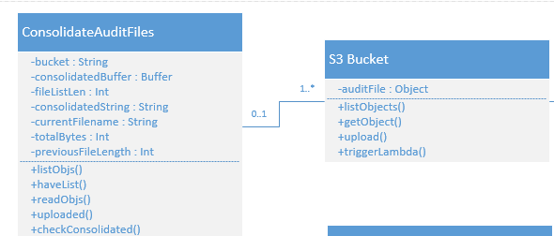

The S3 Bucket – TriggerOnThreshold Class Diagram shown below shows the relationship between the S3 Bucket and the TriggerOnThreshold Lambda Function.

TriggerOnThreshold maintains the srcKey which is the name of the file that was put and triggered the function, the srcDiskUsage which is the value of the diskUsage from the audit file, the srcFirewallStatus which is the value of the firewallStatus from the audit file, the fileBody which is the actual audit file text, and JSONParsed which is the audit file in JSON form to allow for searching of the JSON variables in the audit file. It supports the method:
- checkAlertsSrc: The alert checking function for the put file. In this iteration it checks for Harddisk and Firewall information in the audit file, handles errors, and stores the alert information for output in the console at the end of execution.

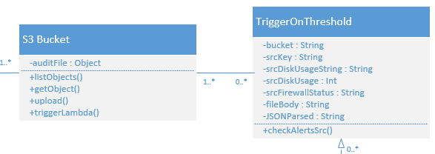

The Dedicated Console – MultipleRunTester Class Diagram shown below shows the relationship between the Demo Console view and the Lambda Function that handles batch uploads of audit files to S3.

The Dedicated Console subscribes to the channel specified and waits for messages on the channel. The page remains blank besides the top and bottom bars and the images until the messages flow in, and when they do it color codes the output of the messages based on the name of the computer for which the alerts are sent.

The MultipleRunTester has many considerations for handling batches of files. It requires many different checks to ensure computation time is not wasted, such as checking for antivirus logs, the configuration file, and the consolidated file on the initial run. If the Source File is any of those, we exit execution to save computation. The MultipleRunTester goes through every file in the bucket, first checks the configuration of the alerts. Then it checks for Antivirus, Firewall, Harddisk, Battery Health and Battery Status alerts, and sends those messages to the PubNub channel specified in the configuration file. Once all the messages for a given source file have been sent, we end execution. The last file (by name) in the bucket will consolidate all the audit files, and a timer is used to ensure that it happens after all the alerts have been sent.
This implementation could be improved with a small database that keeps track of which lambda function is the last to execute, and only on the last function to execute do we consolidate the files in the bucket. In future versions this will certainly be a desired feature.

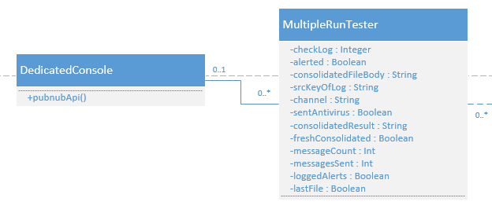

3.3. Dynamic Model
The dynamic functionalities in this project reside in the Lambda Functions, where there are many decision making pieces to process the audit files and prepare for alerting.

Addigy API
This controller drives the putting of audit files into the S3 bucket. It was unmodified during the project and serves as the starting point for audit processing.

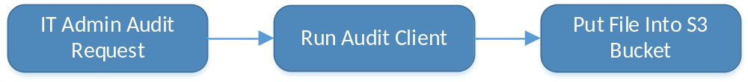
Dedicated Console
The demo console utilizes the Javascript framework to intercept the PubNub Messages and display them in a cleanly formatted way.
The demo console remains blank until it receives messages on the PubNub channel, then it populates the empty space with the messages in div containers on the screen.

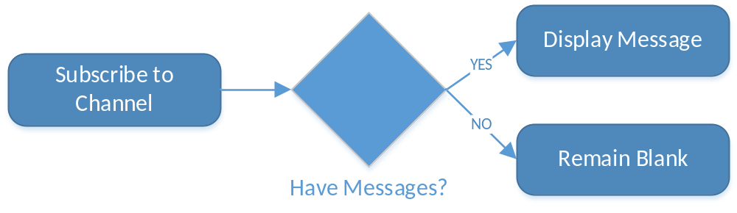

ConsolidateAuditFiles
This function is triggered on a file put event by the Addigy API Controller, and will consolidate all the audit files in the bucket when triggered. It uses the functions provided by S3 to list, get, read, and upload files in the bucket.

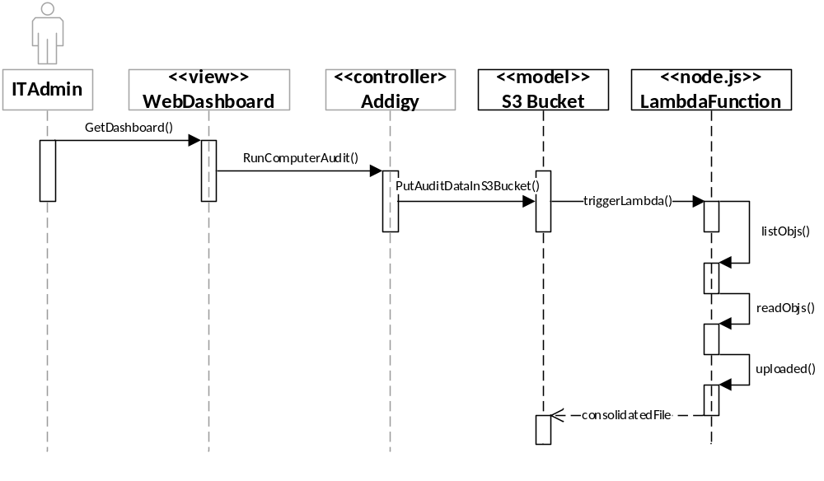
MultipleRunTester
This function is triggered on a file put event by the Addigy API Controller, handle batches of audit files on execution. It uses all of the other Lambda Functions in one streamlined function to send all the alert messages for the batch of audits to the PubNub channel specified in the configuration file.
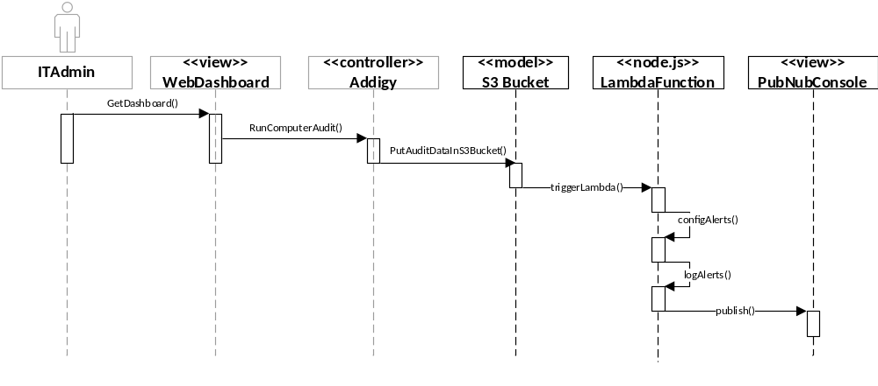

3.4. Code Specifications
Dedicated Console
This view only has the logic associated with subscribing to the channel and stylizing the message boxes with color. Otherwise it is entirely CSS and HTML. The control object is the Javascript framework.

Addigy API
The details for the Addigy API are hidden from the user of this software, and as such there is no code specification for it. It is used only to provide the system with the input of audit files.

S3 Bucket
The inner workings of the S3 functionality are hidden from the user of this software, all operations on bucket contents are accessed through the APIs within S3. The class interface in the class diagram shows those functions that are used in this software. See Appendix C.

Lambda Functions
The Lambda Functions each have their own class interfaces as defined in the Class Diagram in Appendix C. Each Lambda function is pure code that runs on events, so these classes only exist during the execution of each function.

- Glossary
Audit: Detailed machine hardware and software information that is collected via the Addigy software on each client machine.
Facter: Tool used by Addigy software on client machine that collects the audit data to be put into the S3 bucket for processing.

5. Appendix
5.1. Appendix A
Use Cases for Event Driven Cloud Computing:
Use case name
ConsolidateAuditFiles
Participating Actors
- IT Admin
- Mac Addigy Client for Individual Computers
Flow of Events
- IT Admin submits an audit request for a given client computer.
- Request is processed by Addigy service.
- Mac client runs the facter audit for the given machine.
- Audit file is uploaded to the S3 Bucket.
- If audit files for this organization have been consolidated, we are done.
- If audit files have not been consolidated S3 triggers the lambda function ConsolidateAuditFiles.
- ConsolidateAuditFiles returns the consolidated audit file into the S3 bucket.
Exit Condition
All files in the bucket are now consolidated into one file for archiving and use by TriggerOnThreshold.
Exceptions
Cannot read the list of objects, cannot read any individual files, cannot upload to the bucket.
Functional Requirements
Runs in the S3 bucket that calls the Lambda function.
All audit files in the current bucket will be uploaded to S3 into one file.
Nonfunctional Requirements
Each audit file will be separated by a new line character.

Use case name
TriggerOnHarddiskThreshold
Participating Actors
- IT Admin
- Mac Client
Flow of Events
- IT Admin submits an audit request for a given client computer.
- Request is processed by Addigy service.
- Mac client runs the facter audit for the given machine.
- Audit file is uploaded to the S3 Bucket.
- S3 bucket triggers lambda function TriggerOnThreshold.
- Function checks new audit file data for harddisk usage data token.
- If above the desired threshold, create a console log of the alert.
- If no threshold reached, log 'no alert'
Exit Condition
If threshold reached, log the alert. Otherwise, log ‘no alert’ to console.
Exceptions
Cannot read audit file. (Incorrect file format, must be JSON)
Functional Requirements
Runs in the S3 bucket that calls the Lambda function.
Prints alert data to console for viewing in S3.
Nonfunctional Requirements
None.

Use case name
TriggerOnNewThreshold
Participating Actors
- IT Admin
- Mac Client
Flow of Events
- IT Admin submits an audit request for a given client computer.
- Request is processed by Addigy service.
- Mac client runs the facter audit for the given machine.
- Audit file is uploaded to the S3 Bucket.
- S3 bucket triggers lambda function TriggerOnNewThreshold.
- Function checks new audit file data for harddisk usage token and stores it.
- Function checks new audit file data for firewall status token and stores it.
- Function checks old audit data in consolidated file for harddisk usage token and stores it.
- Function checks old audit data in consolidated file for firewall status token and stores it.
- If above the desired threshold and no alert existed previously, create a console log of the alert.
- If firewall status is unchanged or there exists a previous firewall alert, log 'no new alert'.
- If no harddisk threshold reached or there exists a previous harddisk alert, log ‘no new alert’.
Exit Condition
If threshold reached, log the alert. Otherwise, log ‘no alert’ to console.
Exceptions
Cannot read audit file. (Incorrect file format, must be JSON)
Functional Requirements
Runs in the S3 bucket that calls the Lambda function.
Prints alert data to console for viewing in S3.
Nonfunctional Requirements
None.

Use case name
SendPubNubAlert
Participating Actors
- IT Admin
- Mac Client
Flow of Events
- IT Admin submits an audit request for a given client computer.
- Request is processed by Addigy service.
- Mac client runs the facter audit for the given machine.
- Audit file is uploaded to the S3 Bucket.
- S3 bucket triggers lambda function TriggerOnNewThreshold.
- After lambda function returns with alert information, run SendPubNubAlert.
- Function retrieves publisher and subscriber information.
- Function parses alert data into message to be viewed by Admin.
- Function subscribes to the PubNub channel.
- Function sends message on the PubNub channel.
- Channel forwards alert message to be viewed by Admin on WebDashboard.
Exit Condition
Alert successfully sent by function. PubNub channel displays message on console.
Exceptions
Alert cannot be sent.
Cannot connect to message channel.
Functional Requirements
Runs in the S3 bucket that calls the Lambda function.
Sends PubNub message on correct channel and received by Admin.
Nonfunctional Requirements
None.

Use case name
ConfigAlerts
Participating Actors
- IT Admin
- Mac Client
Flow of Events
- IT Admin submits an audit request for a given client computer.
- Request is processed by Addigy service.
- Mac client runs the facter audit for the given machine.
- Audit file is uploaded to the S3 Bucket.
- S3 bucket triggers lambda function ConfigAlerts.
- First function parses the PubNub alert configuration and gets the keys for publisher and subscriber, then it gets the “activated” value to determine if sending PubNub alerts is turned on.
- Next function parses firewall alert configuration and gets the firewall name, value to alert on and activated value.
- Next function parses harddrive alert configuration and gets harddrive name, value to alert on and activated value.
- These flags are passed to triggerOnNewAlert and the alerts are logged to console and PubNub if active.
Exit Condition
Activated alerts show in console and in PubNub if active.
Exceptions
Alert cannot be sent.
Cannot connect to message channel.
Bad consolidated file, cannot be parsed.
Functional Requirements
Runs in the S3 bucket that calls the Lambda function.
Config.json sits in S3 bucket and determines alert behavior.
Nonfunctional Requirements
None.

Use case name
TriggerOnBatteryThreshold
Participating Actors
- IT Admin
- Mac Client
Flow of Events
- IT Admin submits an audit request for a given client computer.
- Request is processed by Addigy service.
- Mac client runs the facter audit for the given machine.
- Audit file is uploaded to the S3 Bucket.
- S3 Bucket triggers lambda function triggerOnBatteryThreshold.
- Function gets battery config from ConfigAlerts for values to alert on.
- Function parses old audit file in consolidated for relevant variables.
- Function parses new audit file for relevant variables.
- Function calculates battery status based on variables in audit files.
- Function gets battery health information from new audit.
- All alert information is formatted for output.
- Calls logAlerts function to output alerts to console and PubNub if activated.
Exit Condition
Antivirus alerts collected and ready to be sent or printed to console.
Exceptions
Bad consolidated file, cannot be parsed.
Functional Requirements
Runs in the S3 bucket that calls the Lambda function.
Battery Config will be in configuration file in bucket.
Nonfunctional Requirements
None.

Use case name
AlertAntivirusLog
Participating Actors
- IT Admin
- Mac Client
Flow of Events
- IT Admin submits an audit request for a given client computer.
- Request is processed by Addigy service.
- Mac client runs the facter audit for the given machine.
- Audit file is uploaded to the S3 Bucket.
- S3 Bucket triggers lambda function AlertAntivirusLog.
- Function checks config file for antivirus configuration and gets the search string to find in the antivirus logs.
- Function checks antivirus log related to audit file that triggered AlertAntivirusLog.
- Function parses log for all relevant lines, an example would be if search string was “quarantine” it would find all the lines that contain the word quarantine and format them for output.
- Function passes alerts to triggerOnNewAlert to output alerts to console and PubNub if activated.
Exit Condition
Antivirus alerts collected and ready to be sent or printed to console.
Exceptions
Alert cannot be sent.
Cannot connect to message channel.
Bad consolidated file, cannot be parsed.
Functional Requirements
Runs in the S3 bucket that calls the Lambda function.
Antivirus log will have same name as audit file with “_log” after the filename.
Nonfunctional Requirements
None.
Use case name
MultipleRunTester
Participating Actors
- IT Admin
- Mac Client
Flow of Events
- IT Admin submits multiple audit requests simultaneously for a given organization’s computers.
- Request is processed by Addigy service.
- Mac client runs the facter audit for the given machines.
- Audit files are uploaded to the S3 Bucket.
- S3 Bucket triggers lambda function MultipleRunTester for each audit file put into bucket.
- Function runs all functionalities from previous user stories on the audit files. Alerts will be stored related to whichever alerts are turned “on” in the config file by using the ConfigAlerts function.
- Alerts are sent to the PubNub channel configured in the config file.
- Alerts can be viewed in the PubNub channel to easily see all the alerts for the organization.
Exit Condition
Alerts for this organization are ready to be viewed in PubNub channel
Exceptions
Alert cannot be sent.
Cannot connect to message channel.
Upload error.
Functional Requirements
Runs in the S3 bucket that calls the Lambda function.
Nonfunctional Requirements
Messages must include hostname in output.

Use case name
DedicatedConsole
Participating Actors
- IT Admin
- Mac Client
Flow of Events
- IT Admin submits multiple audit requests simultaneously for a given organization’s computers.
- Request is processed by Addigy service.
- Mac client runs the facter audit for the given machines.
- Audit files are uploaded to the S3 Bucket.
- S3 Bucket triggers lambda function MultipleRunTester for each audit file put into bucket.
- Alerts are sent to the PubNub channel configured in the config file.
- Alerts will be displayed in a dedicated console window on an HTML page that is linked to the PubNub channel in the config file, for easy viewing on demo day.
Exit Condition
Alerts for this organization are ready to be viewed in Dedicated Console which displays PubNub channel
Exceptions
Alert cannot be sent.
Cannot connect to message channel.
Upload error.
Functional Requirements
Runs in the S3 bucket that calls the Lambda function.
Nonfunctional Requirements
Messages must include hostname in output to identify which computer has the alert

5.2. Appendix B. Use Case Diagram

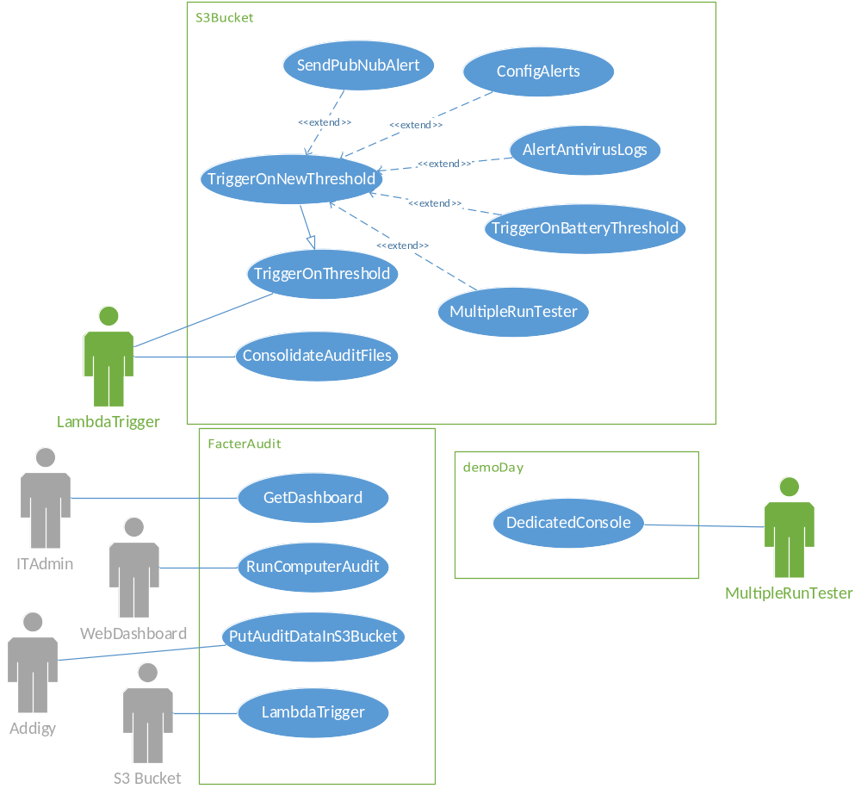

5.3. Appendix C. System Design
The Addigy API in this diagram refers to the controller that handles the audit request and also runs the code that puts the audit into the S3 Bucket. The S3 Bucket then runs event triggers on the audit file put into the bucket, which runs the Lambda Function assigned to the bucket where the file was put. The Lambda functions that alert and send the messages to PubNub interact with the PubNub Console to display the messages in real time, and if the Dedicated Console is open it will also receive the messages from the PubNub Console in the Dedicated Console.
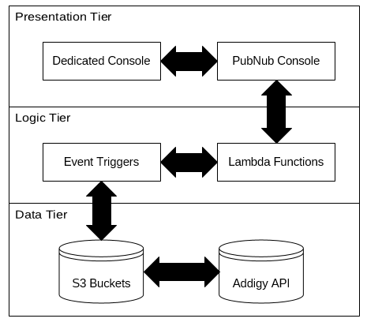

Class Diagram
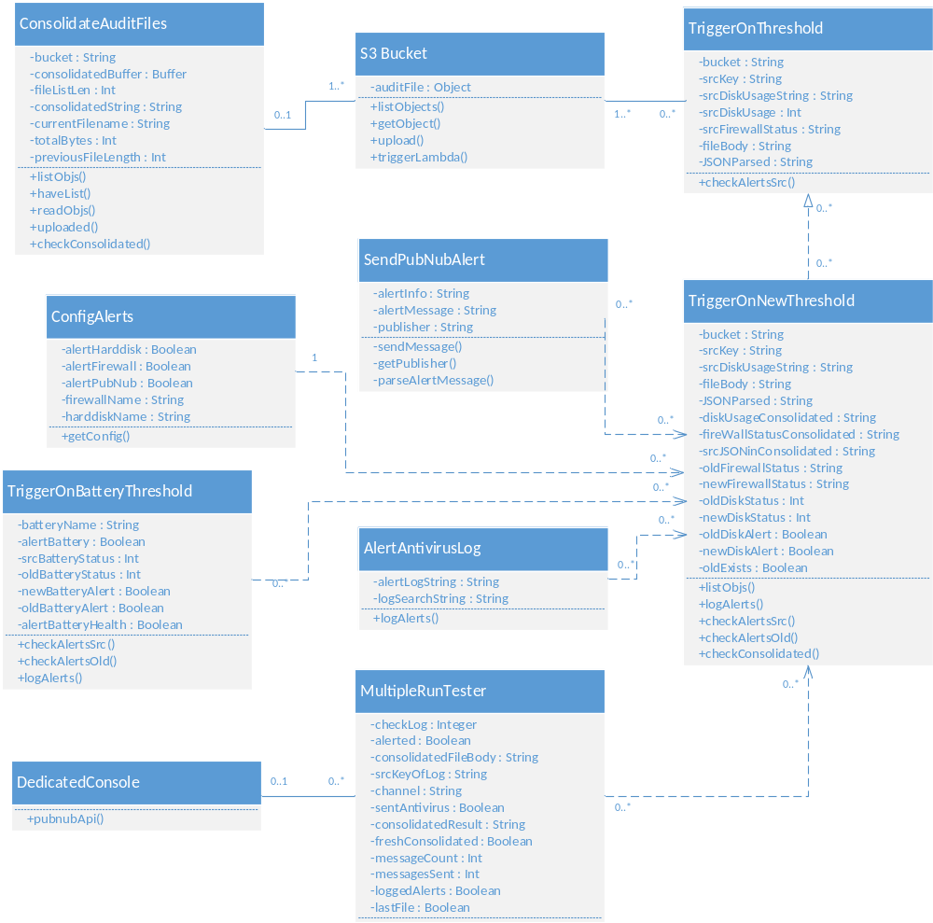

5.4. Appendix D – Diary of Meetings/Tasks
(Gantt chart in Gantt.pdf)
Team Members: | Cory, Alex, Jason
Date: | Jan 20th 2015
Discussions: | We will be building upon the previous web dashboard and adding/modifying functionalities to work with Amazon Web Services, specifically S3 and Lambda functions. We did a general overview of the technologies and discussed meeting times, typically Tuesday and Sunday. We also discussed potential roles regarding how the work would be split up, currently it appears that Cory will deal with backend and Alex will deal with front end. Google documents were set up for the Requirements Document and Feasibility Study & Project Plan.

Team Members: | Cory, Alex, Jason
Date: | Jan 27th 2015
Discussions: | In person meetup, went over tasks for Sprint 1 in detail. Jason created an overview diagram to help us understand the structure of the framework.

Team Members: | Cory, Alex
Date: | Feb 2nd 2015 – Feb 13th 2015
Discussions: | Daily Scrums, discussed what needed to be done and created our scrum cards.

Team Members: | Cory, Alex, Jason
Date: | Feb 17th 2015
Discussions: | Sprint 1 review. Neither of us completed a user story, still having issues with the concepts and the new languages we needed to learn. Sprint 1 retrospectives.

(At this point, Alex dropped the course, I did scrum cards on my own each day but they will not be listed here as they are not technically ‘meetings’)

Team Members: | Cory, Jason
Date: | Feb 24th 2015
Discussions: | In person meetup to go over Sprint 2 progress. Showed Jason what I have completed so far, asked questions regarding implementation. Got feedback, discussed future implementation possibilities.

Team Members: | Cory, Jason
Date: | Mar 3rd 2015
Discussions: | In person meetup to discuss Sprint Presentation. More information regarding infrastructure and implementation. Retrospectives for Sprint 2.

Team Members: | Cory, Jason
Date: | Mar 17th 2015
Discussions: | Online meetup to discuss Sprint 3 progress. Doing well, discussed impediments and results. More background regarding future sprints implementations.

Team Members: | Cory, Jason
Date: | Mar 24th 2015
Discussions: | In person meetup to discuss Sprint 3 presentation. Discussed techniques for getting better scores in presentations, such as making a demo video. Discussed a better solution for IDE than the one I had been using. Got access to PubNub for next user stories.

Team Members: | Cory, Jason
Date: | Mar 31st 2015
Discussions: | Online meetup to discuss Sprint 4 progress. Discuss impediments and potential solutions. Weighing the options against each other. Discuss what we need for demo day and Sprint 4 report.

Team Members: | Cory, Jason
Date: | April 7th 2015
Discussions: | Online meetup to discuss Sprint 4 presentation. Jason happy with feedback and progress on user stories. Discuss in more detail demo day materials and figure out how to accomplish demo day dedicated console page.

Team Members: | Cory, Jason
Date: | April 14th 2015
Discussions: | Online meeting to discuss Sprint 5. Currently things are going smoothly, demo is almost complete and we are up to speed. Discuss generally how demo day usually goes and plan for what to present at showcase.

  - References
http://aws.amazon.com/lambda/pricing/ for pricing information related to AWS and Lambda Functions.

